US ^{How To:}
UniqueSchools
View Picture Permission
View information about which parents have/have not given picture permission for their student(s) via the App CMS.
Click on ‘Reports and filter by student name / year / class.
This information is viewable by all staff and is also viewable via your Communicators App.
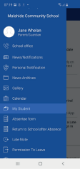
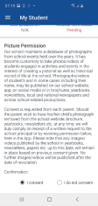
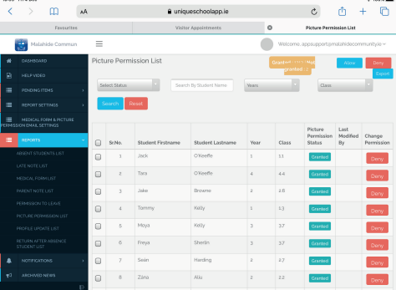
Parents grant or refuse
permission through the ‘My
Student’ module of the App.

